These pages demonstrate how to fill out the PPO Quick Links Template using examples from our demo sites.
For more information about Quick Links and to download the blank template, see our Knowledge Base FAQ page at https://pastperfect.zendesk.com/hc/en-us/articles/24324291110423. If you have any questions, please contact the PPO team at 1-800-562-6080 or email pposupport@museumsoftware.com.
Example 1: Featured Items (Images Only) - https://demo.pastperfectonline.com
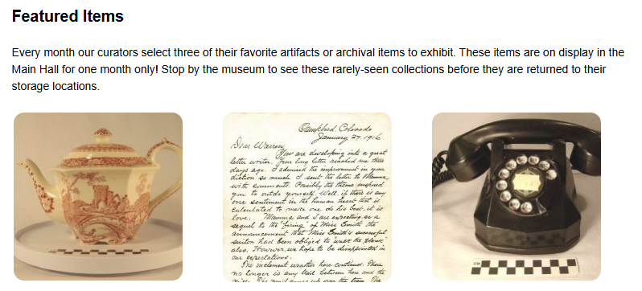
Page Location | Between pricing and “Searching the Collection”
Section Title | Featured Items
Section Text | Every month our curators select three of their favorite artifacts or archival items to exhibit. These items are on display in the Main Hall for one month only! Stop by the museum to see these rarely-seen collections before they are returned to their storage locations.
Additional Notes | Images should all appear in one row and should be 210px square with rounded corners. Images should automatically resize to all remain on the same row when viewing on a phone/small screen.

Link 1
URL | https://demo.pastperfectonline.com/webobject/61E8171C-CADE-4BEE-80F0-531524481693
Image | #4 - side view of teapot with spout on left
Text | n/a

Link 2
URL | https://demo.pastperfectonline.com/archive/23198E3E-8082-4E6A-AD29-344918037275
Image | #1 - page 1
Text | n/a

Link 3
URL | https://demo.pastperfectonline.com/webobject/3798B243-6C12-4DE3-8324-365335996880
Image | #1 - front view with handset on hook
Text | n/a
Example 2: Featured Searches (Text Only) - https://roundleft.pastperfectonline.com
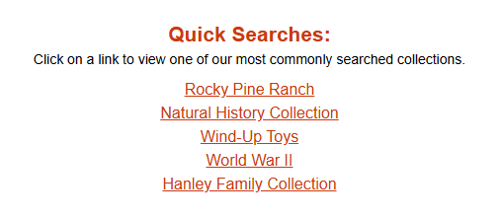
Page Location | After the first paragraph and before “How to Search:”
Section Title | Quick Searches:
Section Text | Click on a link to view one of our most commonly searched collections.
Additional Notes | Links are text-only and should appear on separate lines. This entire section should be centered on the page. Match the title to the “How to Search:” and “Need help?” titles on the page. Links should match other links on the site (e.g., “email our Collections Manager” in the “Need help?” section)

Link 1
URL | https://roundleft.pastperfectonline.com/Search?search_criteria=%22Rocky+Pine+Ranch%22&onlyimages=false
Image | n/a
Text | Rocky Pine Ranch

Link 2
URL | https://roundleft.pastperfectonline.com/Search?search_criteria=%22natural+history%22&onlyimages=false
Image | n/a
Text | Natural History Collection

Link 3
URL | https://roundleft.pastperfectonline.com/Search?search_criteria=mechanical&onlyimages=‌false
Image | n/a
Text | Wind-Up Toys

Link 4
URL | https://roundleft.pastperfectonline.com/Search?search_criteria=%22world+war+II%22&‌onlyimages=false
Image | n/a
Text | World War II

Link 5
URL | https://roundleft.pastperfectonline.com/Search?search_criteria=hanley&onlyimages=false
Image | n/a
Text | Hanley Family Collection

Example 3: Featured Searches (Images & Text) - https://squaretop.pastperfectonline.com
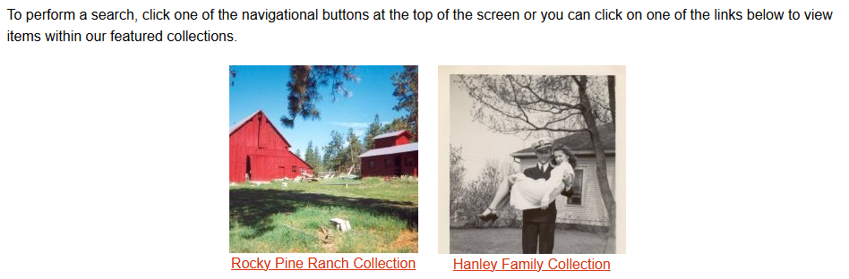
Page Location | Between the first paragraph and “Send Us Feedback”
Section Title | n/a
Introductory Text | To perform a search, click one of the navigational buttons at the top of the screen or you can click on one of the links below to view items within our featured collections.
Additional Notes | The intro text should be left-aligned to match the paragraph above it. Images for each link should appear above their text. Both the images and the text should function as links to their search. The images and their text links should be centered on the page. The images have been emailed as individual PNG files and should be displayed at their full size (210px wide by 210px tall) on a larger screen. When viewed on a mobile device, the images should be resized if necessary to stay on the same row.

Link 1
URL | https://squaretop.pastperfectonline.com/Search?search_criteria=%22Rocky+Pine+Ranch‌%‌2‌2&onlyimages=false
Image | barn.PNG
Text | Rocky Pine Ranch Collection

Link 2
URL | https://squaretop.pastperfectonline.com/Search?search_criteria=Hanley&onlyimages=false
Image | ClairAndHelen_cropped.PNG
Text | Hanley Family Collection

